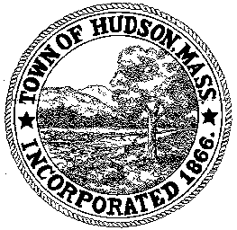

CONSERVATION COMMISSION
78 Main Street, Hudson, MA 01749
(978) 562-2020

Paul Byrne, Chairman W. Minot Wood, Vice Chairman David Esteves, Member

Terrence Joyce, Member Leif Longtine, Member Joseph Rodrigues, Member Al Tashian, Member

Meeting Minutes
July 14, 2011

- Preliminaries
  - Meeting was called to order at 7:00PM
  - Roll Call: Paul Byrne, Al Tashian, Terrence Joyce, David Esteves, Joe Rodrigues and Minot Wood

2.0 New Business
2.1 RDA 408
Location: 91 Park Street
Applicant: Dennis Zilembo/BPOE
Project Description: Build a 52’x10’ bocce court
Minot motioned to close the public hearing and issue a Negative Determination. Motion was seconded by Joe with all in favor 6-0

2.2 James Patry – Eagle Scout Project
James proposed building 2 foot bridges to span the brook at the Danforth Lot. The ConCom suggested doing a topo map with the trails plotted out. Joe will meet with James.

2.3 Voucher
ConCom 063011 $934.07
ConCom 071411 $394.00
Paul motioned to approve the vouchers. Motion was seconded by Minot with all in favor, 6-0

2.4 Minutes – June 30, 2011
Minot motioned to accept the minutes as written. Motion was seconded by Paul with all in favor, 6-0

3.0 Old Business

4.0 Correspondence
4.1 Lake Boon Treatment Plan
4.2 Request for Review and Comment – Bush Road

5.0 Adjournment: Meeting adjourned at 7:50PM

